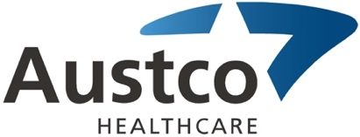
Project Announcement Press Release

FOR IMMEDIATE RELEASE
Austco Healthcare Ltd. Announces $1.3M Project for
Queen Elizabeth Hospital in Adelaide, South Australia

Austco is pleased to announce that our valued partner MCS has been awarded a $1.3m contract for the delivery of the Nurse Call System for the Queen Elizabeth Hospital CSB Project in Adelaide. MCS will install the new 4th Generation Tacera system over the next 12 months.

The project is being delivered by Built Environs and Nilsen Electrical. Their decision to use MCS and Austco is based on proven project delivery by James Hollo and his team at MCS as well as the historic reliability of the Austco products that have been installed in many SA hospitals over the last 20 years.

The project is significant for Austco, as it marks a return to major acute care projects in Australia. Mr. Andy Hall, the recently appointed Austco CCO states “This is a clear indicator that the market is willing to engage Austco for major projects”

Mr. Clayton Astles, Austco’s CEO, states “Our recent investments in developing new products and product features, as well as our revised Australian go-to-market strategy are already paying dividend – we are looking forward to helping Nilsen Electrical, Built Environs, and MCS provide a great public health project for the people of SA.”

About Austco Healthcare Limited (ASX Code – AHC)
Austco Healthcare Limited is an international provider of healthcare communication and clinical workflow management solutions. Headquartered in Australia, the company has subsidiaries in six countries and supports healthcare facilities through its global reseller network, which includes growing markets in health, aged care and acute care. Austco Healthcare services markets including Australia, New Zealand, Canada, UK, USA, Asia and the Middle East. For further information, please refer to the Company’s website www.austcohealthcare.com.

